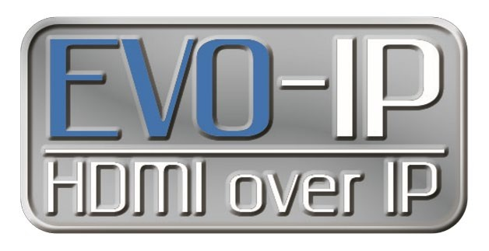
Setting up and Connecting to the Cloud
It is STRONGLY recommended to create an Installer cloud account to get all the features and functionality out of EVO-IP including available firmware update information, iOS/Android mobile app control, remote system monitoring and management, and voice control with Alexa enabled devices.

There are 2 different ways to create, connect, and use a system based on permissions:
INSTALLER which gives full access to the system and remote monitoring capabilities.
END USER which allows for switching, enabling/disabling of video features.

Setting Up and Connecting as an INSTALLER: This is done first and can be used to provide remote access and monitoring as needed. All of your installed Evo-IP systems will be accessible under this account and be used to create additional end user accounts.

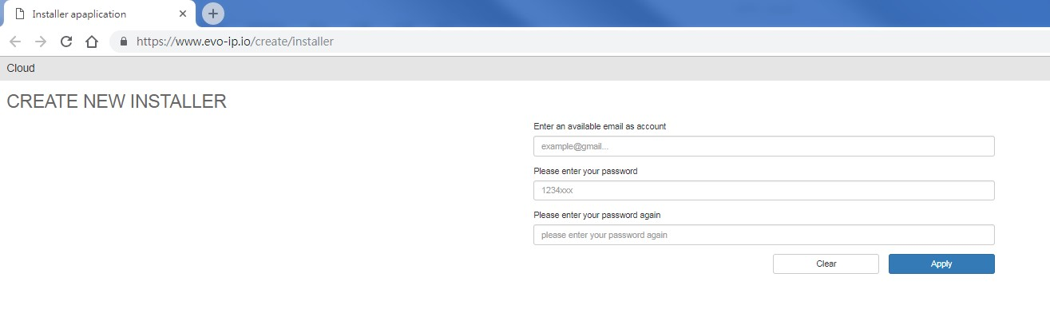
1
. Go to:
https://www.evo-ip.io/create/installe
r

- Enter a valid email address and choose a password.
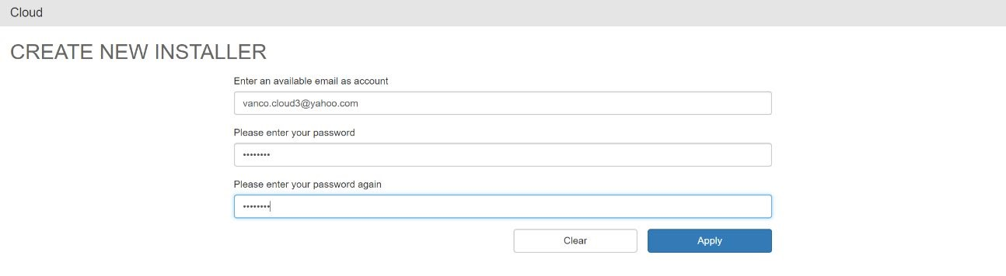

- Check your email. Click on the link to verify the email address, and you will be routed back to the evo-ip.io page.
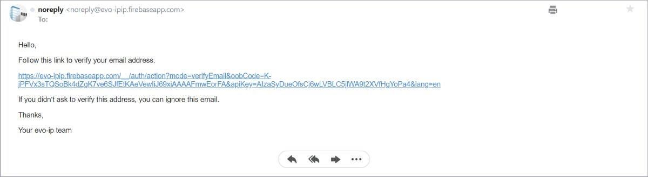

- Once you return to the evo-ip.io page, you will have to add a device (EVOIPCTL1) to your account.

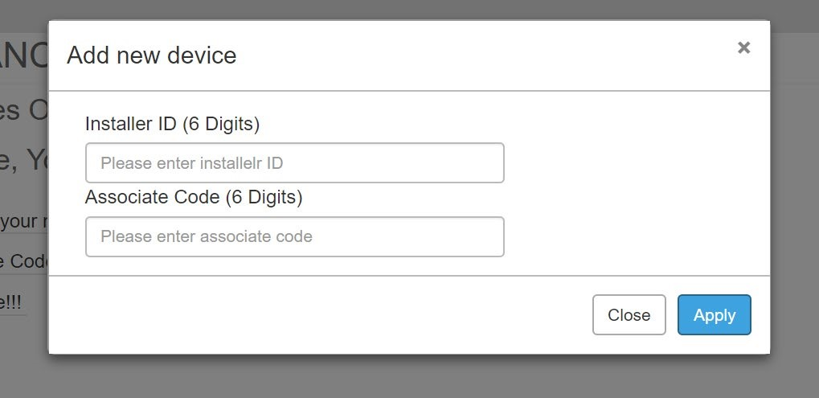

Where to find the Installer ID: The installer ID is specific to your account and is needed to add additional devices and systems under your account. An installer ID number which is found by clicking on your account name on the top right hand side of the window as shown below.
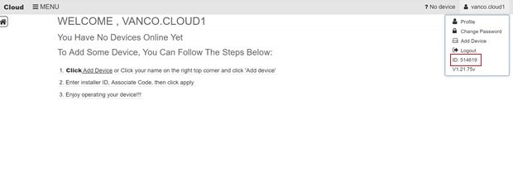
Where to find the Association Code: The Association number is found within the Smart Controller GUI.

GO TO: SMART CONTROLLER (EVO-IP GUI) -> CLOUD (Smart Controller GUI) -> STATUS -> GET CODE
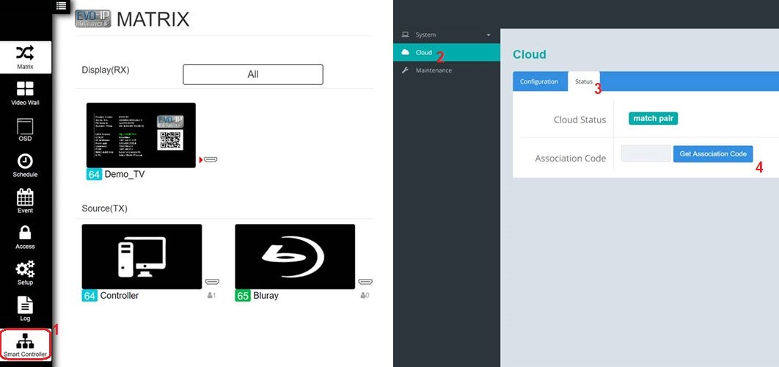
NOTE: This is accessing the Control Box locally, not remotely, and not via the cloud.
NOTE: IF THE ASSOCIATION CODE IS NOT SUBMITTED WITHIN 2 MINUTES, A NEW ASSOCIATION CODE WILL BE NEEDED.
- Enter the Association Code and Installer ID into the appropriate fields, click APPLY and you will be routed to the Cloud and Device(s) homepage. Click on your Profile name in the upper right hand corner to rename the Controller for each application to log into different accounts, change passwords or add other devices.

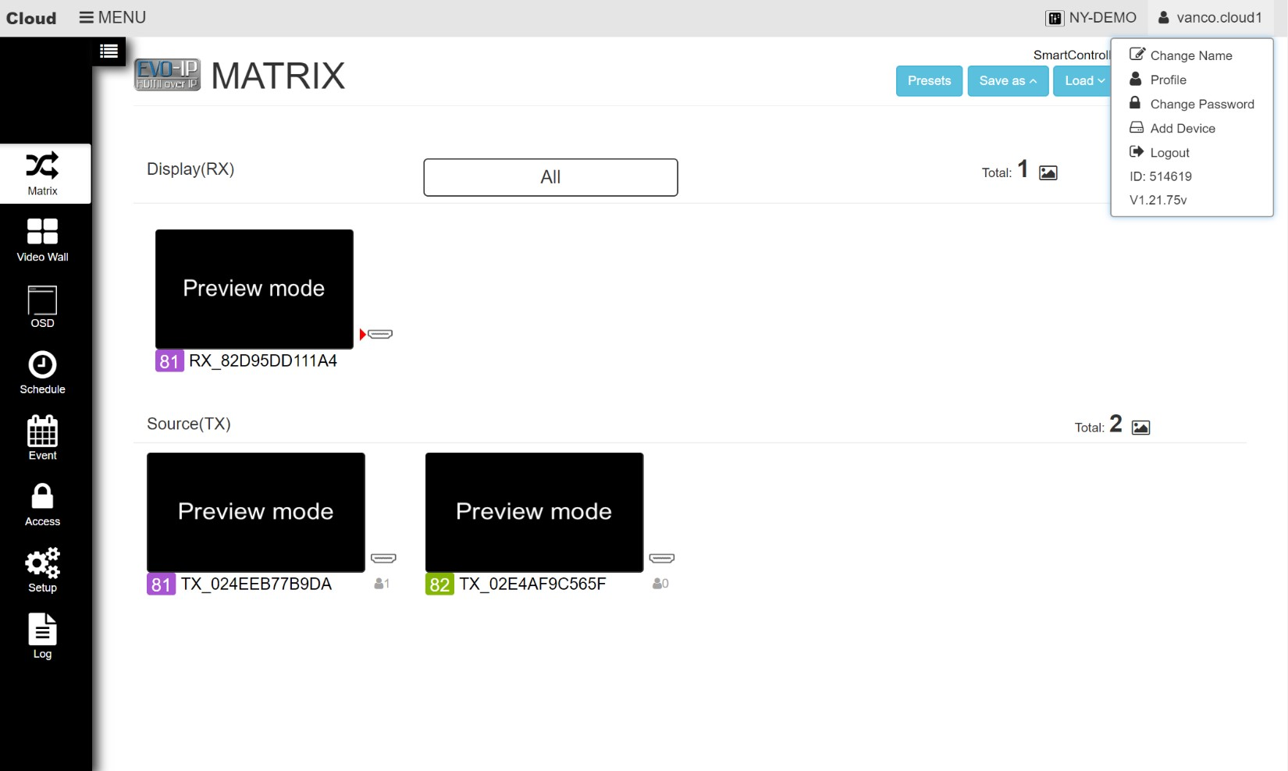

- You can also click on the device name to view, select, and manage other systems connected through the same cloud account and select a favorite to come up when the screen first opens.

Setting Up and Connecting as an END USER:

- Go to: https://www.evo-ip.io

- Click on “Create New Account” and then enter the END USER’s email and set desired password.

- Confirm the account by going to the email account used to create the cloud account. Click on the link to verify the email address, and you will be routed back to the evo-ip.io page.

- Once you return to the evo-ip.io page, to give the END USER access, click on “Add New Device”. Use YOUR Installer ID, and the Association Code which is found within the Smart Controller GUI.

NOTE: YOU NEED TO USE THE INSTALLER ID THAT WAS USED AND PROVIDED WHEN CREATING THE INSTALLER ACCOUNT
Where to find the Association Code:
NOTE: This is accessing the Control Box locally, not remotely, and not via the cloud.

GO TO: SMART CONTROLLER (EVO-IP GUI) -> CLOUD (Smart Controller GUI)->STATUS-> GET CODE

NOTE: IF THE ASSOCIATION CODE IS NOT SUBMITTED WITHIN 2 MINUTES, A NEW ASSOCIATION CODE WILL BE NEEDED.

- Click on the USER profile on the upper right hand corner to change the name of the Controller, change Display Name, set favorite device, change password, and add new device.

Note that END USER only has access to Matrix, Video Wall, OSD, and Schedule modes only.

