BAV2500/BAV4250
Firmware Update Guide

1. Connect Ethernet cable to PC from the amp.

2. Turn off AMP by AC power switch.

3. Hold the BACK button circled below.

4. Turn on unit (the LED lights will flash rapidly) and release the BACK button.
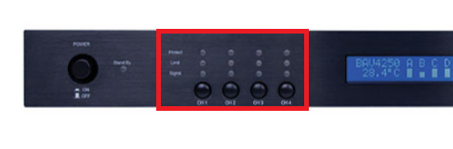

5. Open the update tool.

6. Once the unit is detected, type in the device IP address and press CONNECT.
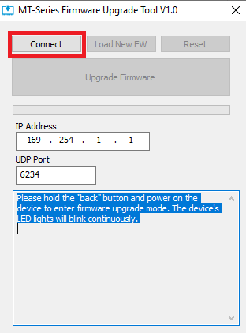
7. Press “load new FW”, find and load the correct FW file, then select UPGRADE FIRMWARE. Available firmware files will be posted on www.vanco1.com for this product.

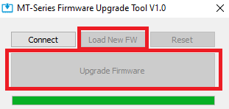

8. Power Cycle the amp. Log in to the GUI to confirm changes.

