280531
Cat5e/6 Pinout Configuration

Below is the Cat5e/6 pinout configuration for the 280531. We always recommend utilizing all pairs found within your category cable but understand when unnecessary pairs can be used for other purposes while on the job site.
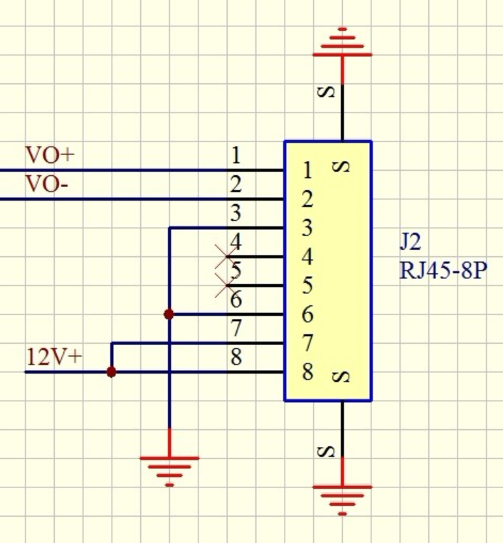

Pins 4 and 5 of the Cat5e/6 are not necessary for other functions within the product. When terminating to the 568A or 568B standard, this would be the BLUE/BLUE-WHITE pair.

