
Ubiquiti Configuration

Single Switch
The EVO-IP HDMI over IP System has been tested and confirmed to work with Ubiquiti EdgeSwitch Switches. Below are screenshots showing the configuration needed to get the system up and running once you have installed the Ubiquiti software. We recommend your switch is updated to the latest Ubiquiti Edge series firmware.

- Go to Configuration tab and Admin Mode to Enable and click submit.
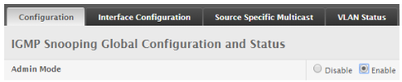

- Go to Interface Configuration and select ALL from the Display Rows drop down menu. Check the upper most check box to highlight all switch ports then choose EDIT at the bottom.

- Set Admin Mode and Admin Fast Leave to Enable then submit.
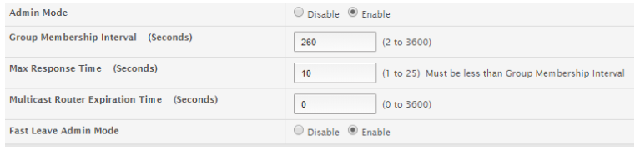

- Go to VLAN STATUS and click the ADD button. Set Fast Leave Admin Mode and Report Suppression to Enable.
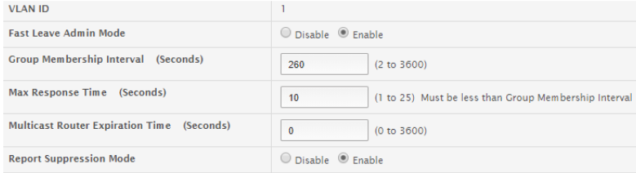

- On the Main Menu, select SWITCHING and then IGMP Snooping Querier. Set Admin Mode to Enable, enter the IP address of the control box as the IP ADDRESS, select IGMPv2.
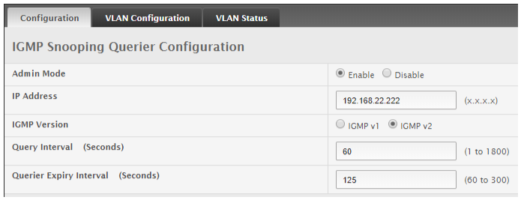

- Select VLAN Configuration TAB next and select ADD. Enable Querier Election Participation, and set the IP address of the control box as the Querier VLAN IP Address.
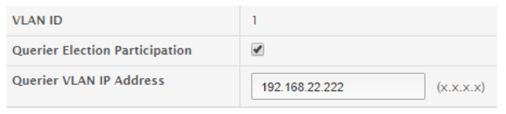

- In the Main Menu select SYSTEM and then choose PORT. Select DISPLAY ROWS from the drop down menu and choose ALL. Again check the upper most check box to highlight all switch ports and choose EDIT. Set the Max Frame Size to 9216 and submit.
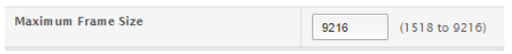

- Once completed, make sure you click on the SAVE CONFIGURATION button on the top right of the window or all settings will be brought back to default. Once the settings are saved, reboot the switch and test.

