Netgear Switch Configuration

The EVO-IP HDMI over IP System has been tested and confirmed to work with Netgear GS728TPv2 and GS728TPPv2 ethernet switches. Below are screenshots showing the configuration needed to get the EVO-IP system up and running. Please refer to Netgear’s manual and instructions on how to access the settings.

- Log into switch by going to 192.168.0.239 (default IP address for switch)
  - Default password is password
- Click on Switching
- Within the Ports tab, enter 10000 into the Frame Size field and click Apply.
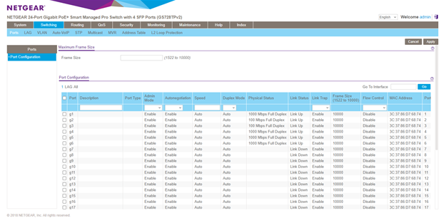
- Click on the Multicast tab, then select IGMP Snooping from the menu on the left

- Click to enable IGMP Snooping Status then click Apply
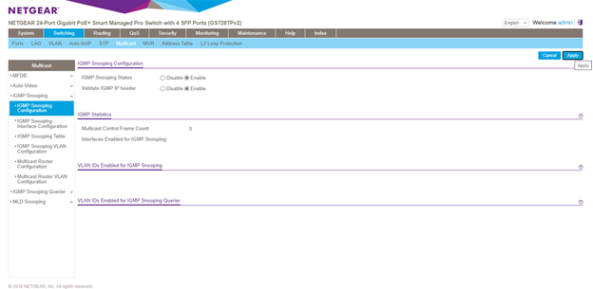
- Next go to IGMP Snooping Interface tab on the left.
- Click on the top left check box to select all, and select ENABLE from the Admin Mode and Fast Leave Mode drop down menus. After click Apply.
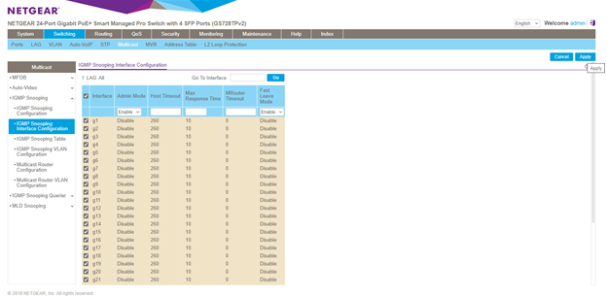
- Select IGMP Snooping VLAN Configuration from the menu on the left.
- Click on the checkbox to select VLAN 1 (default). Then select Enable from the Admin Mode and Fast Leave Mode and click Apply.
