Netgear M4250 Series Switches
The EVO-IP HDMI over IP System has been tested and confirmed to work with the Netgear M4250 series switches. Below are screenshots (used with M4250-10GF-POE+) showing the configuration needed to get the system up and running. Please refer for additional networking needs and information.

Single Switch Configuration

- Connect your computer to the Netgear Switch OOB Port and log into the switch to access and change settings. Please note that you will need to ensure you computer’s Ethernet port is configured to be within the same subnet based on the default IP addresses listed below.
OOB Port: enter default IP address of 192.168.0.239
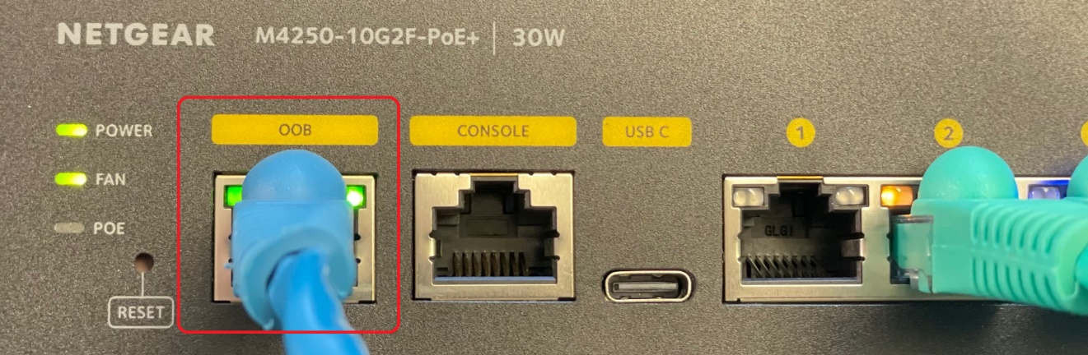
- Login to either the AV UI or Main UI.
AV UI/Main UI: Enter admin for the username and leave the password field blank when logging into the UI for the first time.
NOTE: We recommend using the AV UI for a more streamlined setup as shown below.
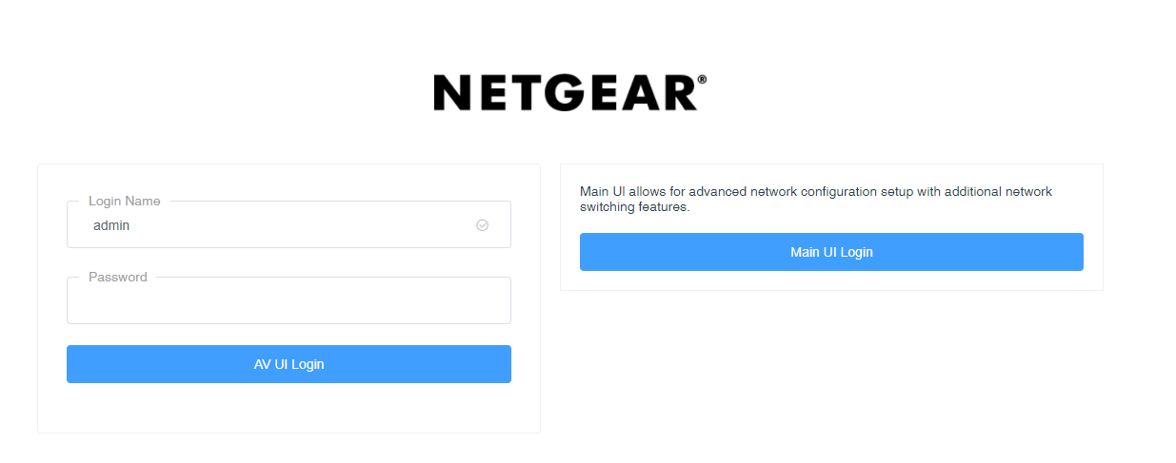

- At this point you will be prompted to create a new default password. Enter the new password into both fields and click Save when you are ready to proceed. You will be asked to login in again using the newly created password.
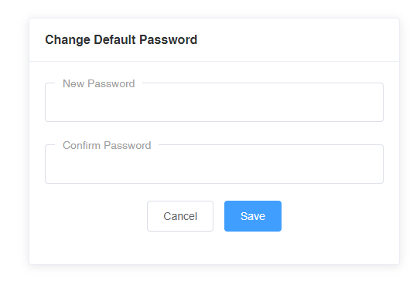
- This will bring you the Overview page. This provides helpful information regarding the switch status. You can over a mouse over each port as well for additional port information.
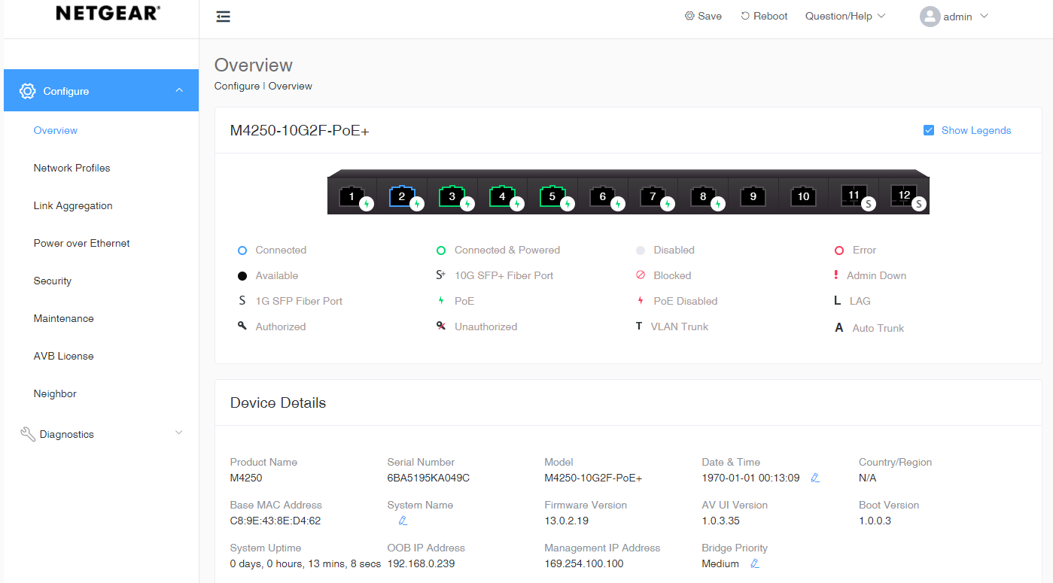
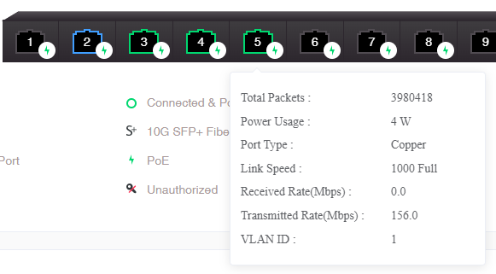
- Select Network Profiles from the column on the left and scroll down to see Management VLAN, and click on the icon on the right of the screen, and select Edit.
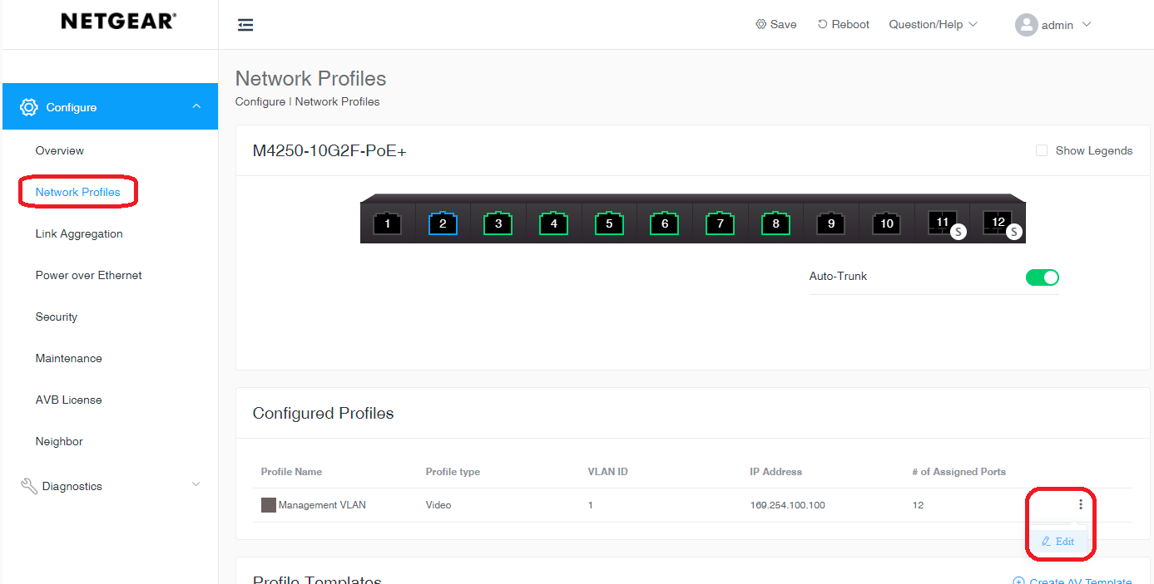

- A window will pop up to edit the profile. Click on the Profile Template dropdown menu and select Video, then click Save.
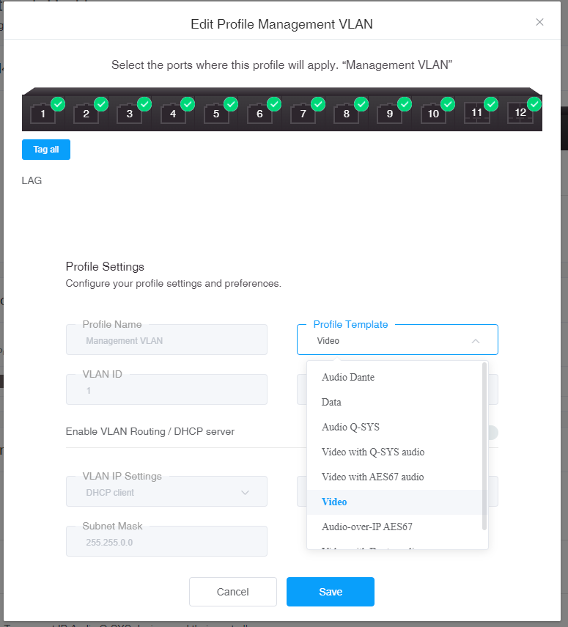
Note: Here you can also select EVO-IP specific ports needed to be used for the installation. Other VLANs/profiles would need to be created if other products lie on the same switch and need to be separate from EVOIP products as needed.

- Once you return to the main page, click Save on the top of the screen, and then Reboot.
Note: If transmitters or receivers seem to be discolored, physically power cycle the switch using the power switch on the unit.

- Once the switch has been rebooted, connect the Cat cable going from the computer to a regular port on the switch that was included and selected within the Management VLAN profile.

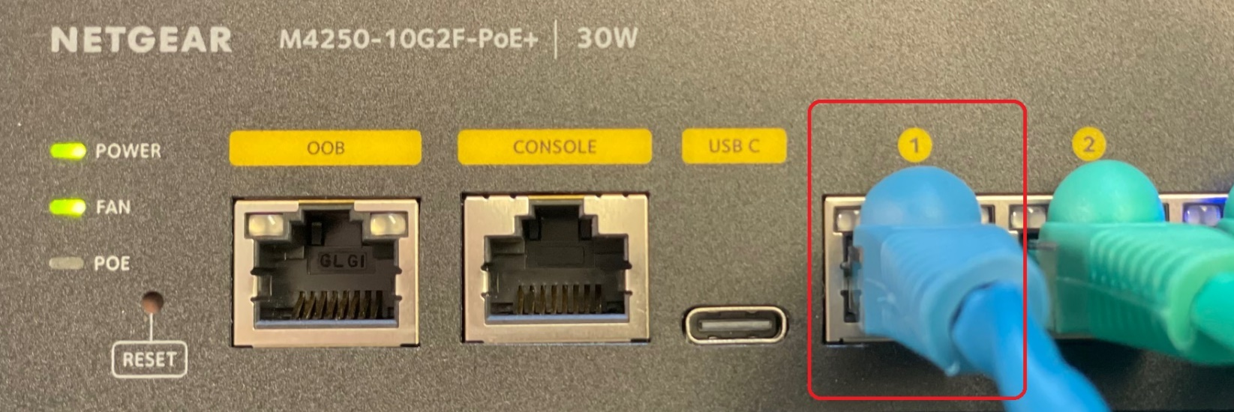

- You can now access the EVOIP unit for setup and control.

Multiple Switch Configuration

Netgear M4250 series switches are designed to make setup of multiple switch AV over IP configurations simple. When using EVOIPTX1 and EVOIPRX1 devices (up to 850Mbps), it is important to use switches with 10G Uplink ports. You can use M4250 series switches when using EVOIPLITE (up to 45Mbps) but will likely require multiple uplinks between switches based on the system design. Please refer to Netgear documentation for recommended cabling and modules.

Auto-Trunk feature automatically configures the interconnect between switches.
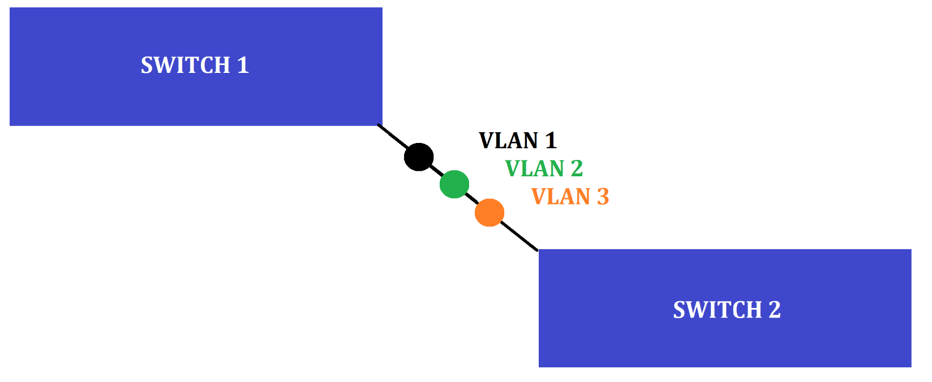

Auto-LAG dynamically creates a link aggregation group if there is more than one link between two switches.
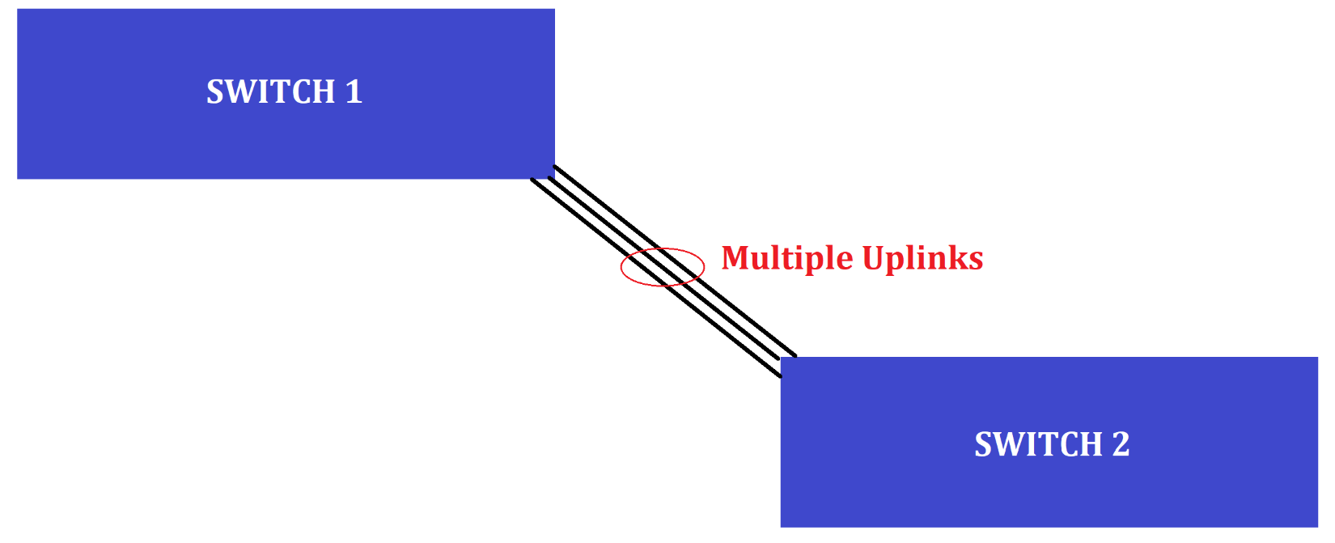
Creating a Static LAG for Extended Switches: Follow the steps for a single switch configuration before proceeding to the instruction below to set up extended switches.

- Click on Configure from the menu on the left.
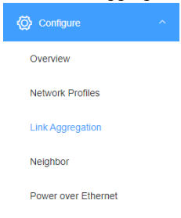
- Click on Create LAG found on the right side of the screen.
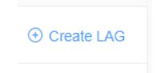
- Select the ports that you want to be included in the LAG, then enter a LAG NAME, select an ID from the dropdown menu, and click to enable Static LAG.
