

**Ubiquiti Configuration**

# Single Switch

The EVO-IP HDMI over IP System has been tested and confirmed to work with Ubiquiti EdgeSwitch Switches. Below are screenshots showing the configuration needed to get the system up and running once you have installed the Ubiquiti software. We recommend your switch is updated to the latest Ubiquiti Edge series firmware.

1. Go to **Configuration** tab and **Admin Mode** to **Enable** and click submit.

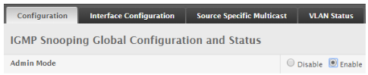

1. Go to Interface Configuration and select **ALL** from the Display Rows drop down menu. Check the upper most check box to highlight all switch ports then choose **EDIT** at the bottom.
2. Set **Admin Mode** and **Admin Fast Leave** to **Enable** then submit.

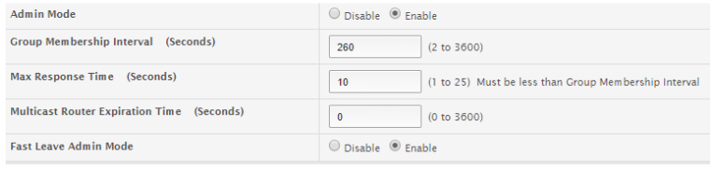

1. Go to **VLAN STATUS** and click the **ADD** button. Set **Fast Leave Admin Mode** and **Report Suppression** to **Enable**.

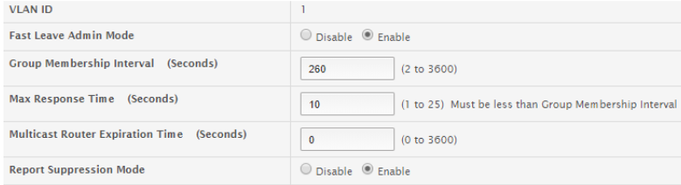

1. On the **Main Menu**, select **SWITCHING** and then **IGMP Snooping Querier**. Set **Admin Mode** to **Enable**, enter the IP address of the control box as the **IP ADDRESS**, select **IGMPv2**.

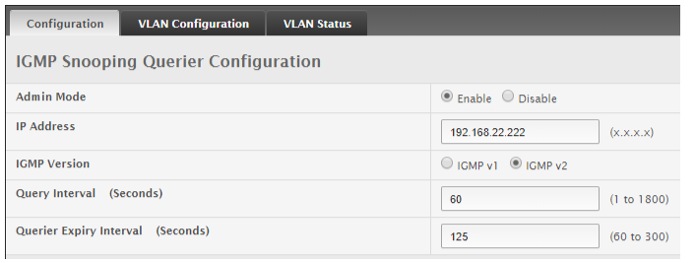

1. Select **VLAN Configuration TAB** next and select **ADD**. **Enable Querier Election Participation**, and set the **IP address** of the control box as the **Querier VLAN IP Address**.

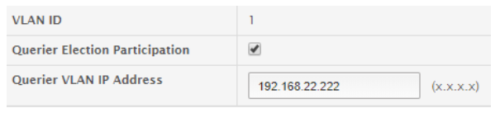

1. In the **Main Menu** select **SYSTEM** and then choose **PORT**. Select **DISPLAY ROWS** from the drop down menu and choose **ALL**. Again check the upper most check box to highlight all switch ports and choose **EDIT**. Set the **Max Frame Size** to **9216** and submit.

cid:image009.png@01D5CA1C.7ABC6640

1. Once completed, make sure you click on the **SAVE CONFIGURATION** button on the top right of the window or all settings will be brought back to default. Once the settings are saved, reboot the switch and test.