Video Wall Bezel Adjustment

Video Wall bezel adjustment is highly customizable using the Evo-IP web browser interface and allows for the creation and manipulation of content in many ways for up to 25 displays.

To adjust the bezel of a particular screen in the video wall, first make sure your video wall in configured with the proper source(s) and displays. Click on a particular display, then select the BEZEL button.
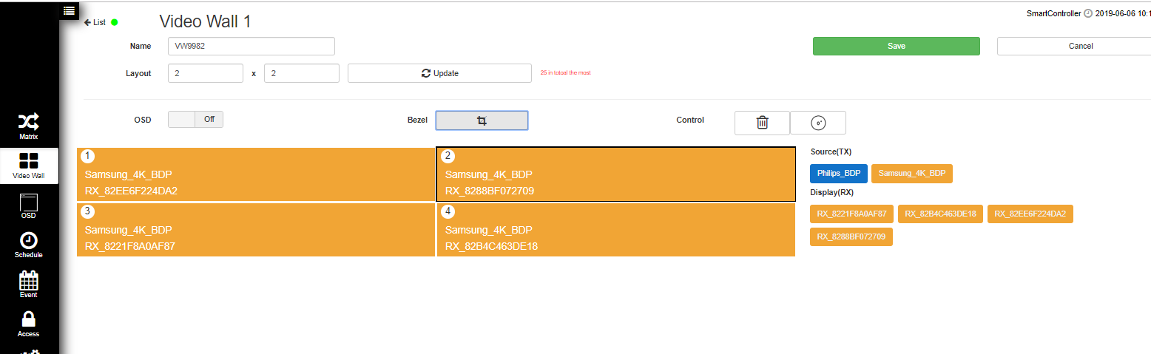

The following screen will come up with X1, Y1 and X2, Y2, along with a Test, Apply, and Cancel button.
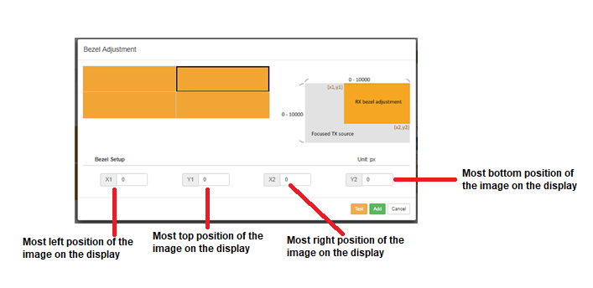

The Bezel Adjustment is based on an X, Y graphing system where the most top left point of the video wall is labeled (0,0) and the most bottom right point of the video wall is (10000, 10000). The middle of a video is represented by the coordinates of (5000, 5000). Below are other commons points to help manipulate and correct the image for different bezel types and displays.
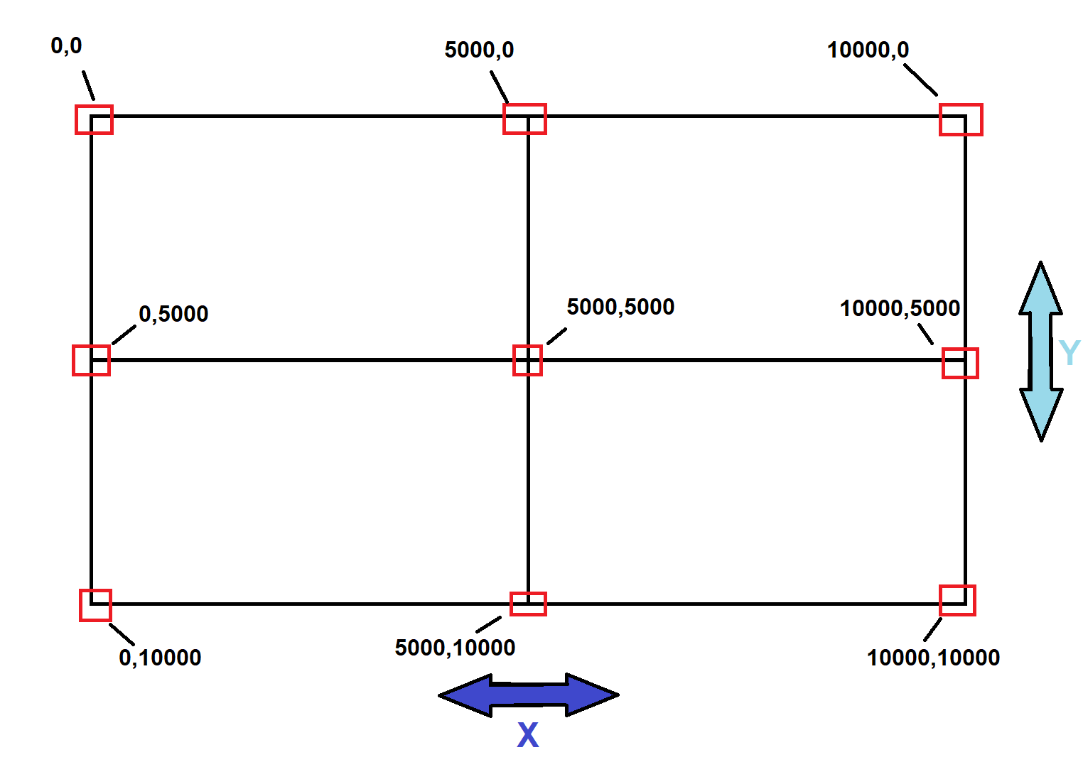

For example: on a 2x2 video wall, the bezel on the top left needs to be moved on the left hand side to the left (X axis) and down more from the bottom (Y axis).

- The starting coordinates for X1 and Y1 would be 0,0 as the image does not need to be changed on the top and left boarders. This would be entered for X1, and Y1 Fields.
- The center of the video wall where all 4 displays meet is 5000,5000. This can be typed in as a starting point for the X2 and Y2 fields.
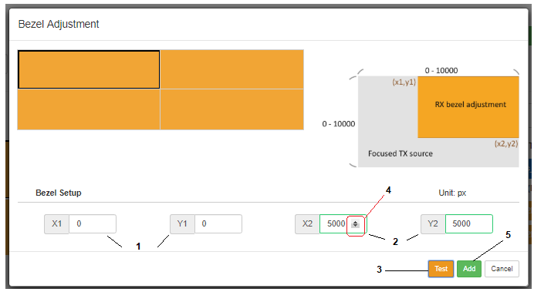
- Click on test to make sure no changes were made
  - Video wall needs to be enabled first
- Type in or use the up and down arrows (move boundary left/right or up/down) to change the field(s) as needed.
  - Select TEST again to see how the wall has changed.
  - Repeat as necessary
- Click Apply on the Bezel Adjustment window and you will return to Video Wall Setup
  - Make sure you click SAVE to save any changes made to the bezels.

