Setting up and controlling EVO-IP with Alexa

Once your EVO-IP system is connected to the cloud, you now have the ability to setup your systems to be voice controlled using the EVO-IP Alexa Skill.

- In the mobile Alexa app, go to Skills (or Skills & Games depending on the app version).
- Touch the search icon (magnifying glass) in the top right, and when prompted type in evoip then touch Search and the EVO-IP skill will come up. Select the EVO-IP skill to enter the setup.
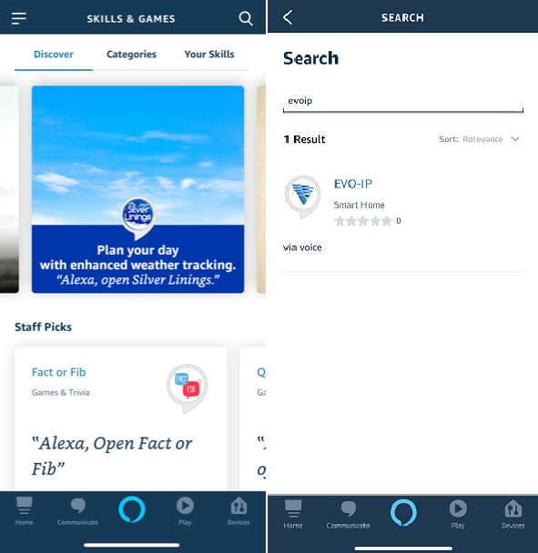
- Next touch Enable To Use and a new window will open up to sign into your EVO-IP cloud account.
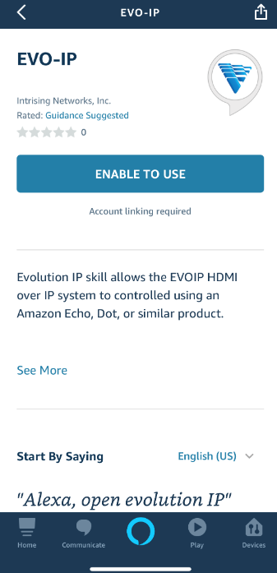
- Enter your username(email) and password and touch Sign In. If done correctly the window will state EVO-IP has been successfully linked. Once you touch Done in the upper left corner, you will be returned to the Alexa app and EVO-IP Skill.
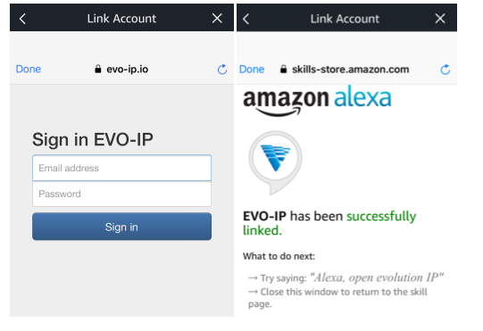
NOTE: IF THIS WAS NOT DONE CORRECTLY, WHEN YOU RETURN TO THE EVO-IP SKILL SCREEN IT WILL STATE THAT ACCOUNT LINKING IS REQUIRED
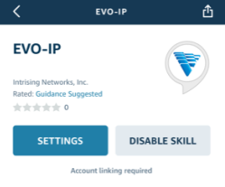

Now that EVO-IP is setup with the Alexa skill, you can now use voice control to control your system. Below is the default string of voice commands needed to switch sources, enable presets, and to enable/disable video walls.

Alexa Prompt Structure
Alexa | open | Evo | IP
Alexa | set | (display name) | to | (source name)
Example: Alexa, set Living Room to Sony 4K Bluray player
Alexa | Switch | (source name) | to | (display name)
Example: Alexa, switch Sony 4K Bluray player to Living room
Alexa | Enable | Mapping | Preset | (number)
Example: Alexa, enable preset 1
Alexa | Enable/Disable | (Video Wall Name)
Example: Alexa, enable Bar
*Say "no" "Stop" "Cancel" to end the skill

It is VERY important to note that the names that are given to the transmitters (sources) and receivers (displays) in the initial EVO-IP setup directly impact the names used for voice control. Below is a default list of input and output names that can be used for voice commands within the system.

NOTE: We understand the custom nature of this product and are more than happy to help in any way to accommodate additional names and labels within the EVO-IP Alexa skill.

INPUTS/SOURCES
Input 1 | Source 1 | Bluray 1 | Denon Bluray Player | Xbox X
Input 2 | Source 2 | Bluray 2 | Insignia Bluray | Playstation
Input 3 | Source 3 | Bluray 3 | Insignia DVD | Playstation 3
Input 4 | Source 4 | Bluray 4 | Insignia Bluray Player | Playstation 4
Input 5 | Source 5 | Bluray 5 | Magnavox Bluray | Playstation 4 PRO
Input 6 | Source 6 | Bluray 6 | Magnavox DVD | Sony 4k
Input 7 | Source 7 | Bluray 7 | Magnavox Bluray Player | LG 4k
Input 8 | Source 8 | Bluray 8 | Marantz Bluray | Phillips 4K
Input 9 | Source 9 | Bluray 9 | Marantz DVD | Samsung 4K
Input 10 | Source 10 | Bluray 10 | Marantz Bluray Player | Computer
Input 11 | Source 11 | Sony Bluray | Memorex Bluray | Computer 1
Input 12 | Source 12 | Sony Media Player | Memorex DVD | Computer 2
Input 13 | Source 13 | Sony DVD | Memorex Bluray Player | Computer 3
Input 14 | Source 14 | Sony Bluray Player | Onkyo Bluray | Computer 4
Input 15 | Source 15 | LG Bluray | Onkyo DVD | Computer 5
Input 16 | Source 16 | LG DVD | Onkyo Bluray Player | Computer 6
Input 17 | Source 17 | LG Bluray Player | Pioneer Bluray | Computer 7
Input 18 | Source 18 | Samsung Bluray | Pioneer DVD | Computer 8
Input 19 | Source 19 | Samsung DVD | Pioneer Bluray Player | Computer 9
Input 20 | Source 20 | Samsung Media Player | Sharp Bluray | Computer 10
Input 21 | Source 21 | Samsung Bluray Player | Sharp DVD | Tablet
Input 22 | Source 22 | Oppo Bluray | Sharp Bluray Player | Phone
Input 23 | Source 23 | Oppo DVD | Toshiba Bluray | Camera
Input 24 | Source 24 | Oppo Bluray Player | Toshiba DVD | Camera 1
Input 25 | Source 25 | Phillips Bluray | Toshiba Bluray Player | Camera 2
Input 26 | Source 26 | Phillips DVD | Wii | Camera 3
Input 27 | Source 27 | Phillips Bluray Player | Wii U | Camera 4
Input 28 | Source 28 | Panasonic Bluray | Wii Switch | Camera 5
Input 29 | Source 29 | Panasonic DVD | Xbox | Camera 6
Input 30 | Source 30 | Panasonic Bluray Player | Xbox 360 | Camera 7
Input 31 | Source 31 | Denon Bluray | Xbox One | Camera 8
Input 32 | Source 32 | Denon DVD | Xboxb One S | Camera 9
Xbox X | NVR | His Sat box | Amazon Fire | Joey
Playstation | NVR 1 | Her Cable Box | Roku Stick | Joey 1
Playstation 3 | NVR 2 | His Cable Box | Computer Stick | Joey 2
Playstation 4 | NVR 3 | Her Sat Box | Man Cave | Joey 3
Playstation 4 PRO | NVR 4 | His DVR | Man Cave in a Box | Joey 4
Sony 4k | NVR 5 | Her DVR | EVSW1040 | Joey 5
LG 4k | DVR | Apple TV | EVSW21MV | Joey 6
Phillips 4K | DVR 1 | Apple TV 1 | Picture in Picture | Joey 7
Samsung 4K | DVR 2 | Apple TV 2 | Security Cameras | Joey 8
Computer | DVR 3 | Apple TV 3 | Directv | Joey 9
Computer 1 | DVR 4 | Apple TV 4 | Directv client 1 | Joey 10
Computer 2 | DVR 5 | Apple TV 5 | Directv client 2 | 4K Bluray Player
Computer 3 | Cable Box | 4K Apple TV | Directv client 3 | Spectrum Box
Computer 4 | Cable Box 1 | Roku Box | Directv client 4 | Comcast Box
Computer 5 | Cable Box 2 | Roku | Directv client 5 | Uverse Box
Computer 6 | Cable Box 3 | Roku 1 | Directv client 6 | Fios Box
Computer 7 | Cable Box 4 | Roku 2 | Directv client 7 | Verizon Fios
Computer 8 | Cable Box 5 | Roku 3 | Directv client 8 | Verizon Fios 1
Computer 9 | Cable Box 6 | Roku 4 | Directv client 9 | Verizon Fios 2
Computer 10 | Cable Box 7 | Roku 5 | Dish | Verizon Fios 3
Tablet | Cable Box 8 | Sat 1 | Dish Hopper | Verizon Fios 4
Phone | Cable Box 9 | Sat 2 | Dish Hopper 1 | Verizon Fios 5
Camera | Cable Box 10 | Sat 3 | Dish Hopper 2 | Verizon Fios 6
Camera 1 | Sat Box | Sat 4 | Dish Hopper 3 | Verizon Fios 7
Camera 2 | Sat Box 1 | Sat 5 | Dish Hopper 4 | Verizon Fios 8
Camera 3 | Sat Box 2 | Sat 6 | Dish Hopper 5 | Verizon Fios 9
Camera 4 | Sat Box 3 | Sat 7 | Dish Hopper 6 | Verizon Fios 10
Camera 5 | Sat Box 4 | Sat 8 | Dish Hopper 7
Camera 6 | Sat Box 5 | Sat 9 | Dish Hopper 8
Camera 7 | Sat Box 6 | Sat 10 | Dish Hopper 9
Camera 8 | Sat Box 7 | Fire Stick | Dish Hopper 10
Camera 9 | Sat Box 8 | Fire TV
Camera 10 | Sat Box 9
 | Sat Box 10

OUTPUTS/DISPLAYS
Output 1 | Zone 1 | Living Room | Spa
Output 2 | Zone 2 | Family Room | Theater Room
Output 3 | Zone 3 | Den | Home Theater
Output 4 | Zone 4 | Kitchen | Video Wall 1
Output 5 | Zone 5 | Dining Room | Video Wall 2
Output 6 | Zone 6 | Pool | Video Wall 3
Output 7 | Zone 7 | Spa | Video Wall 4
Output 8 | Zone 8 | Hot Tub | Video Wall 5
Output 9 | Zone 9 | Bathroom 1 | Video Wall 6
Output 10 | Zone 10 | Bathroom 2 | Video Wall 7
Output 11 | Zone 11 | Bathtroom 3 | Video Wall 8
Output 12 | Zone 12 | Bathroom 4 | Video Wall 9
Output 13 | Zone 13 | Bathroom 5 | Video Wall 10
Output 14 | Zone 14 | Master Bathroom | Ballroom
Output 15 | Zone 15 | Master Bathroom | Hall
Output 16 | Zone 16 | Master Bedroom | Office
Output 17 | Zone 17 | Guest Bedroom | Desk
Output 18 | Zone 18 | Guest Room | Main
Output 19 | Zone 19 | Sauna | 4K TV
Output 20 | Zone 20 | Basement | 4K Samsung
Output 21 | Zone 21 | Garage | 4K Sony
Output 22 | Zone 22 | Man Cave | 4K LG
Output 23 | Zone 23 | Game Room | 4K Vizio
Output 24 | Zone 24 | Bar 1
Output 25 | Zone 25 | Bar 2
Output 26 | Zone 26 | Bar 3
Output 27 | Zone 27 | Bar 4
Output 28 | Zone 28 | Bar 5
Output 29 | Zone 29 | Dungeon
Output 30 | Zone 30 | Kids Room
Output 31 | Zone 31 | Front Porch
Output 32 | Zone 32 | Back Porch

