EVSP14VW
Multiple Unit Video Wall

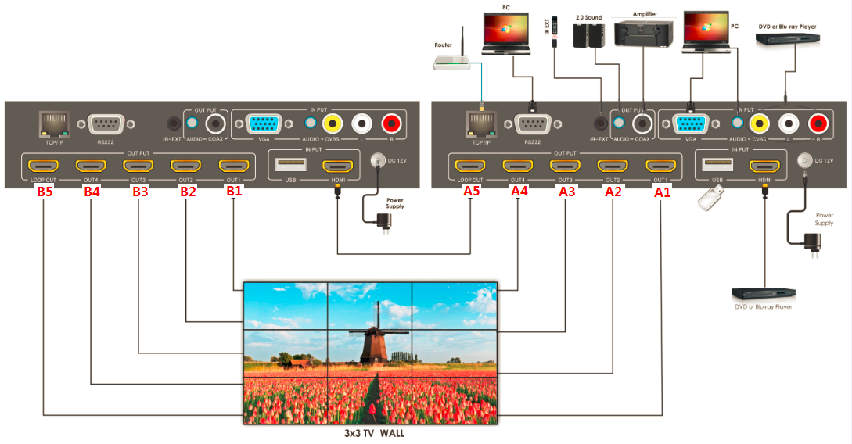
- Connect your sources such as a Blu-Ray Player, game console, USB flash drive, Cable or Satellite Receiver, etc. to the unit with the appropriate type of connection (HDMI, VGA, Composite, USB). Insert and extract cables carefully with the power switched off. Connecting and disconnecting while the unit is powered can result in damage to circuitry.
- Connect the HDMI output(s) to the displays in order of how you would like them to appear within the video wall (see ADDITIONAL VIDEO WALL CONFIGURATIONS)
- Connect a HDMI cable from the LOOP OUT port of the first unit into the HDMI input of the second unit.
- Connect the HDMI output(s) of the second EVSP14VW to the displays in order of how you would like them to appear within the video wall
- OPTIONAL: Connect an RS-232 cable from the RS232 port on the switch, RJ45 to the TCP/IP port, or the provided IR Receiver into the IR EXT port for further control.
- Connect the provided 12V power supply to the port on the unit
- Connect the power supply to an available electrical outlet and power on the device.

Additional Video Wall Configurations
While there are presets that exist within the provided software, additional configurations can be created using commands by identifying the main unit (A) and the subunits (B).

1x2(H)
1x3(H) | 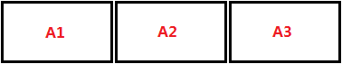
1x4(H)
1x2(V) | 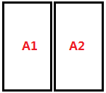
1x3(V) | 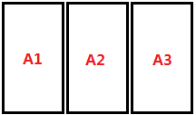
1x4(V) | 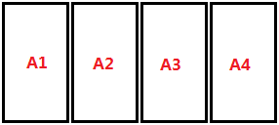
2x1 | 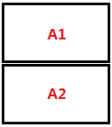
3x1 | 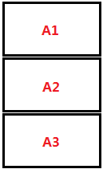
4x1 | 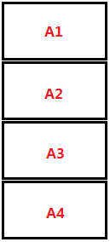
2x2 | 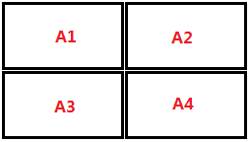

Cascade 2
2x3 | 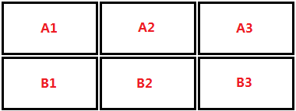
3x2 | 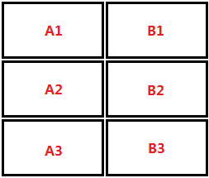
2x4 | 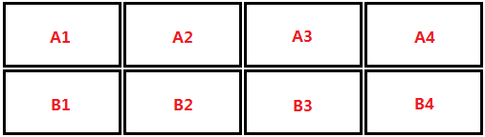
4x2 | 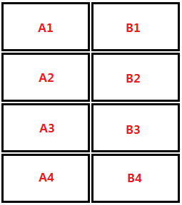
3x3 | 