EVSP24VW
Daisy Chaining and Cascade Modes

The EVSP24VW supports daisy chaining and cascade modes to support larger video wall configurations, as well to provide additional sources. It is important to note that control of multiple units can ONLY be done using RS232. As always it is important to set up the units correctly before proceeding. Visit the product webpage at www.vanco1.com for additional information and documentation.

Daisey Chaining multiple units allows the same 2 sources to be able to be accessed to multiple units that make up larger video wall configurations. HDMI Loopouts A and B/Main of Device 1, are simply connected to Inputs A and B/Main of Device 2 as shown below.
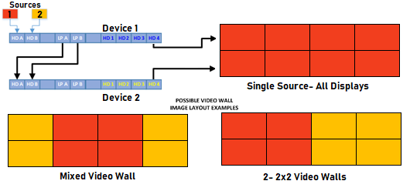

Cascading multiple units allows 1 common source to be shared from Device 1 and allows ADDITIONAL sources to be connected to the other attached units for even more video wall capabilities! To accomplish this, connect a single source to Input A on Device 1. Then connect the HDMI Loopout port B/Main of Device 1 into the HDMI Input B on the Device 2. This will allow you to connect another source into the HDMI Input A port of Device 2. The example below shows 4 units being cascaded while being able to use 4 sources for additional video wall configurations and possibilities.
