IR HEX Codes for Vanco 280711 HDMI 3x1 Switch with IR Control

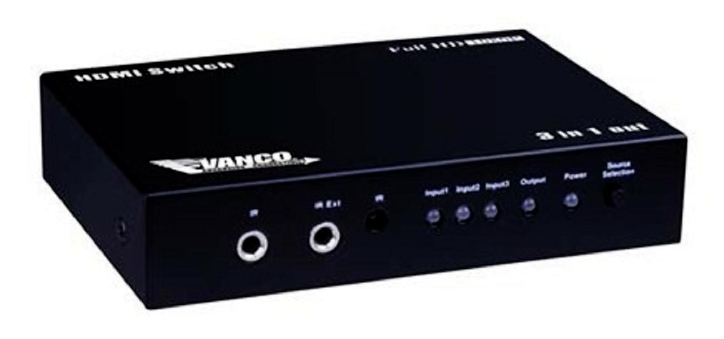
IR HEX CODES:

Output1: left keys: 00FF5C
Output1: right keys: 00FF1E
Output1: number 1 keys: 00FF17
Output1: number 2 keys: 00FF5D
Output1: number 3 keys: 00FF1C

Customer code: 00FF

