DBT-Taylor
Downloading and Installing the DBT-Taylor App on Android Devices
Due to changes within the Google Play marketplace, the DBT-Taylor app is being updated to be uploaded onto the Google Play marketplace. Below are instructions on how to download, install, and open the DBT-Taylor app.

- Download the DBT-Taylor .apk file from email, or from the Downloads tab of the DBT-Taylor product page found at www.vanco1.com.
- Once downloaded, select Open File or you may need to locate the path where files go after being downloaded on your device, and find the .apk file named DBT-Taylor V1.7.8.8.apk .
NOTE: This can differ between devices depending on the brand, model, and apps used on the device.
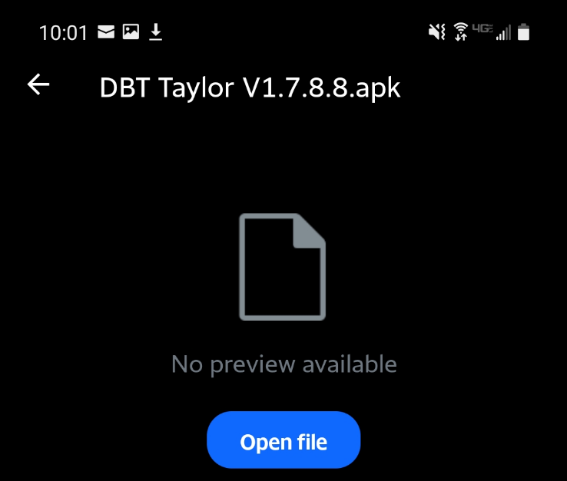

- Once located, select OPEN FILE. At this point, you will be prompted to change security settings to be allowed to install unknown apps unless (unless this was already done for other 3rd party applications). Select Settings.
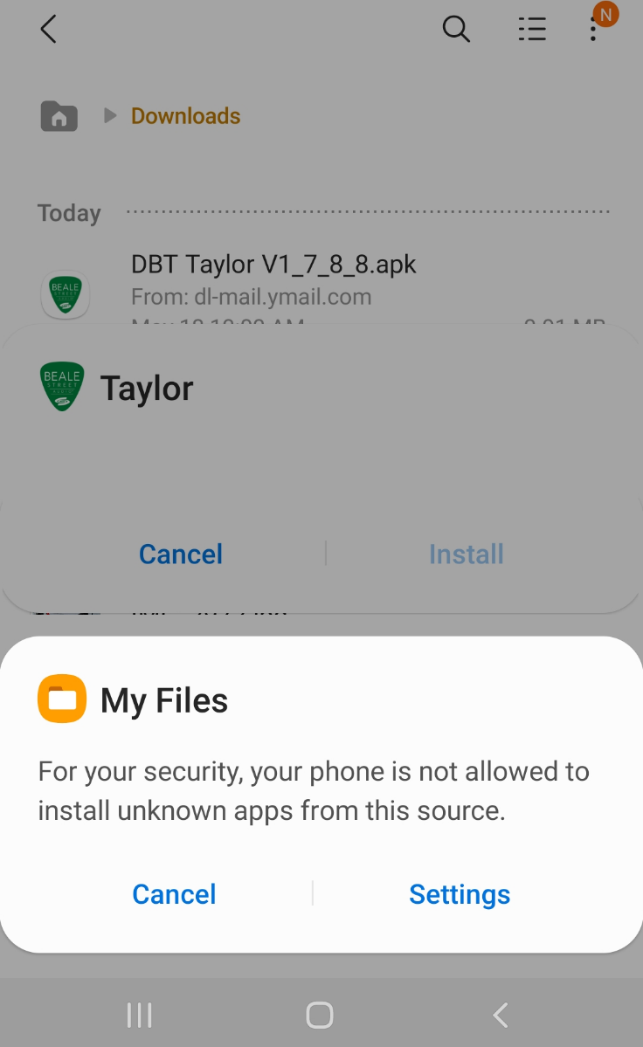

- Once in the settings, you want to make sure that under Install Unknown Apps is ENABLED as shown in the image below. Once enabled, you can select the back button on the top left or simply go back to where the .apk file was downloaded and stored.
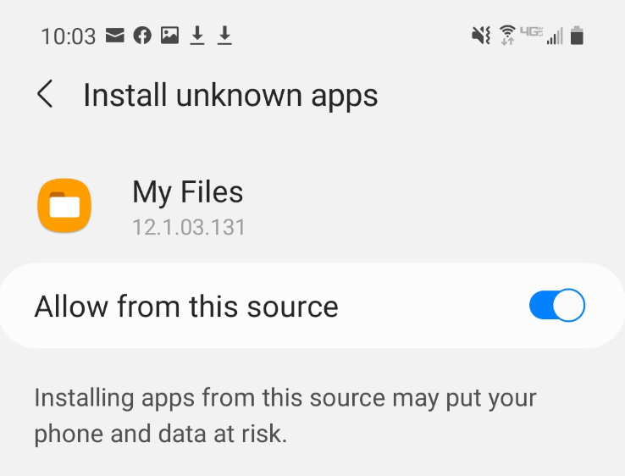

- Select the DBT Taylor V1.7.8.8.1.apk to start installing the app to your android device. You will be prompted to allow the app to access storage. Make sure it is ENABLED and select Continue to finish installing the app.
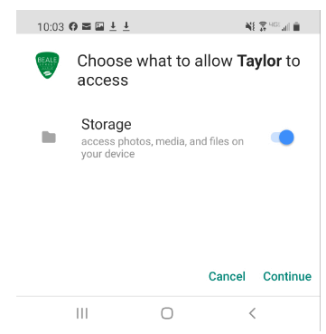
- Once the app is finished installing, a pop up will ask to Open the DBT Taylor app, or select Done to close the pop up. The DBT Taylor app is now ready for use.
